

MEDIA PRODUCTION AND ANALYSIS SAMPLE EXAMINATION

Section 7 of the New WACE Manual: General Information 2006–2009 outlines the policy on WACE examinations.

Further information about the WACE Examinations policy can be accessed from the Curriculum Council website at http://newwace.curriculum.wa.edu.au/pages/about_wace_manual.asp.

Please note:
This sample examination was developed prior to changes to exam requirements and is presented only as a sample that could be useful in assisting teachers to develop tasks for school assessment. Note: There are changes to time suggestions for each section as per the refined Exam Design Brief. Please refer to correspondence from David Wood, Chief Executive Officer, Curriculum Council dated 4 April 2007 and the Exam Design Brief on the WACE website at http://newwace.curriculum.wa.edu.au/docs/COS_docs/179238_1.doc for accurate details of the exam structure for 2007.
For additional sample examination items, please refer to the Exam Item Bank at http://newwace.curriculum.wa.edu.au/pages/courses/course_media_exam_item_bank.asp for a collection of sample questions.
Fine tuning to the exam structure took place following consultation with teachers, measurement specialists and advice from the Assessment, Review and Moderation (ARM) panel.

input.doc




Sample WACE Examination

Question/Answer Booklet

MEDIA
Please place your student identification label in this box
PRODUCTION
AND ANALYSIS

Student Number: In figures

In words

Time allowed for this paper
Reading/planning time before commencing work: Ten minutes
Working time for paper: Three hours

Material required/recommended for this paper

To be provided by the supervisor
This Question/Answer Booklet
One spare, loose page for working/planning – not for submission.

To be provided by the candidate
Standard items: Pens, pencils, eraser or correction fluid, ruler, highlighter, printed English language dictionary and/or bilingual dictionary (non electronic and not a thesaurus)

Important note to candidates
No other items may be taken into the examination room. It is your responsibility to ensure that you do not have any unauthorised notes or other items of a non-personal nature in the examination room. If you have any unauthorised material with you, hand it to the supervisor before reading any further.

Structure of this paper

Section | Outcomes | Suggested working time | Number of questions available | Number of questions to be attempted
Section A | 3 and 4 | 45 mins | 3 | 3
Section B | 1 | 90 mins | 3 | 3
Section C | 3 and 4 | 45 mins | 1 | 1

Instructions to candidates

- The rules for the conduct of Curriculum Council examinations are detailed in the Student Information Handbook. Sitting this examination implies that you agree to abide by these rules.

- Answer the questions according to the following instructions:
Sections A, B and C. Answer all questions.

- Write your answers in the spaces provided in this Question/Answer Booklet. A blue or black ballpoint or ink pen should be used.

- You must be careful to confine your responses to the specific questions asked and to follow any instructions that are specific to a particular question. Where no specific instructions are given, you should feel free to use a range of formats to express your knowledge and understandings.

- Spare answer pages may be found at the end of this booklet. If you need to use them, indicate in the original answer space where the answer is continued (i.e. give the page number).

- A spare loose page has been provided to assist your working and planning. No material on the loose page will be marked, and this page is not to be submitted with this exam paper.

Section A

There are THREE questions in this section. You are required to answer ALL the questions.
Allow approximately 45 minutes for this section [32 marks].

Question 1 refers to aspects of Media Language.
Question 2 refers to aspects of Audience.
Question 3 refers to aspects of Production.

Your response to each question is to be made in relation to one of the images below and one of the media works described below.

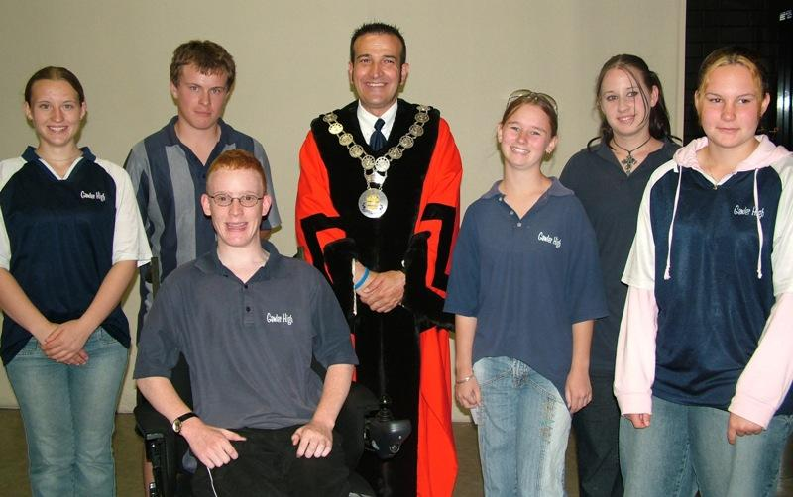
Image 1
(Conboy, 2005)

Image 2
(Mellon College of Science, n.d.)
You must choose ONE of the following examples only to answer any of the three options.

- This image is part of a film poster to promote a new Australian film
OR
- This image is part of the opening credit sequence for a new television program or film entitled The School
OR
- This image is part of a newspaper report or magazine article on the Australian education system

Question 1
Discuss one of the following:

- how the form of media will have an impact on the final product
OR
- how the codes and conventions used in the image position audiences to respond to the text in a particular way
OR
- how the representation of people serves the interests of particular groups
[8 marks].

Tick the box to indicate the form of text that you will discuss for all three questions:

 | POSTER |  | TV/FILM
 | NEWSPAPER REPORT/  MAGAZINE ARTICLE | Alternative media form

Question 2
Explain how the text you have chosen to write about will appeal to the values and expectations of the target audience
[12 marks].

Question 3

Explain how the text will be influenced by one of the following:
- institutional controls
OR
- production constraints
OR
- cultural contexts.
[12 marks].

THIS PAGE HAS BEEN LEFT BLANK INTENTIONALLY
Section B

There are THREE questions in this section. You are required to answer ALL the questions.
Allow approximately 90 minutes for this section [33 marks].

All three questions in this section which are based on the development of a script/design plan. All of your answers are to be made in reference to the same media form chosen from the following:

 | television
 | newspaper
 | magazine
 | radio
 | website
 | other (please specify)

Tick the box to show the media form you have selected. Your responses to questions 4, 5 and 6 will all relate to this form.

Question 4
Create a script/design plan to advertise or promote a television program entitled The School to target a specific audience for your selected media form. Use the layout provided.

- Outline the profile of your target audience. Consider:

- age, gender, socio-economic group, sub-cultural group/s
- cultural background, lifestyle, media experiences and preferences
- values, beliefs and attitudes. [5 marks].

Script/Design Plan
age, gender,
socio-economic group, sub-cultural group/s

cultural background

lifestyle

media experiences and preferences

values, beliefs and attitudes

- Discuss why you have chosen this form to promote the program, considering the:

- advantages and limitations of the form (e.g. technologies and audience use)
- audience preferences and expectations of the form. [6 marks].

Script/Design Plan (continued)
Advantages
Limitations

Audience preferences and expectations

- Provide a list of possible ideas and/or techniques to be used in your script/design plan. Justify their use. [6 marks].

Ideas and techniques | Justification

Question 5

Develop your script/design plan for the advertisement/promotion you developed in Question 4.

- Write a brief synopsis description of your advertisement or promotion outlining features of the program, sets or locations, plots and characters that you intend to highlight for your audience. [5 marks].

Note: The standard length for a film, television or radio commercial is thirty (30) seconds.

- From your synopsis/description, develop and present your storyboard, script or layout, for your advertisement / promotion using ONE of the formats on the next three pages, or a format of your own choice on blank pages provided. [10 marks]

STORYBOARD - for your advertisement/promotion

Note: You will be judged on your ability to select appropriate codes and conventions rather than your drawing ability.

WRITTEN SCRIPT

Shot number | Camera distance and angle | Shot description | Audio | Shot duration
RADIO SCRIPT

Time | Running duration | Dialogue/announcement | Sound FX

This page has been left blank for you to develop and present your storyboard, script or layout in a format of your own choice.

This page has been left blank for you to develop and present your storyboard, script or layout in a format of your own choice.
Question 6

Explain how the production context and particular constraints might influence the style and content of your advertisement/promotion.
[6 marks].

Section C

There is only ONE question in this section. You should choose one of the options to answer Question 7.

Allow approximately 45 minutes for this section [30 marks]

Question 7

(i) ‘The media is the most powerful entity on earth. They have the power to make the innocent guilty and to make the guilty innocent, and that is power. Because they control the minds of the masses.’ (Malcolm X)

Discuss your agreement or disagreement with this statement referring to your understanding of the role of the audience in accepting and resisting media messages.

OR

(ii) With reference to at least one media text studied this year discuss your understanding of the following:
- How the text has attempted to be persuasive.
- How the text reinforced, challenged or contributed to the values and attitudes of the audience.
- How the historical and cultural context has influenced the production of the text.

OR

(iii) Discuss your understanding of the way that a specific culture exploits the use of various media to gain control and/or maintain power. Your answer should refer to your understanding of least two of the following:
- globalization
- cultural imperialism
- reporting world events
- propaganda and political censorship in different cultures

OR

(iv) The ABC’s Australian Story has been described as “…a tapestry of the tales of our country’s people, in all their diversity…a work of art and identity…”

With reference to at least one media text studied this year, discuss your understanding of media as an art form. Your answer should refer to some of the following;
- alternative and experimental media forms and styles such as photo-journalism,
- non-realist narratives,
- use of codes and conventions to create a specific effect,
- contemporary and traditional genre,
- alternative representations of issues and events.

SPACE FOR EXTRA WORKING

SPACE FOR EXTRA WORKING

SPACE FOR EXTRA WORKING

SPACE FOR EXTRA WORKING

END OF PAPER

ACKNOWLEDGEMENTS

SECTION A

Image 1: Conboy, R. (2005). [Photograph of citizenship ceremony organised by Gawler High School students]. Retrieved November 11, 2006, from Civics and Citizenship Education website: http://www.civicsandcitizenship.edu.au/verve/_resources/citizens2.JPG.

Image 2: Mellon College of Science. (n.d.). [Image of students in science laboratory]. Retrieved November 15, 2006, from Carnegie Mellon website: http://www.cmu.edu/mcs/images/photos/pgss2005-group.jpg.

Published by the Curriculum Council of Western Australia
27 Walters Drive
OSBORNE PARK WA 6017

